Add an Assignment 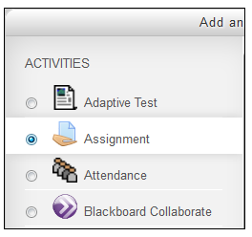
Use an assignment to have students submit work electronically by uploading a document or by working online within the Moodle course.

Contents
- How to Create an Assignment
- Assignment Settings

Create an Assignment
- Go to the course home page.
- Click on the Turn editing on button at the top right of the page.
- Click Add an activity or resource in the Module where you would like to insert an assignment.

- Click on the radio button next to Assignment and click on the Add button.

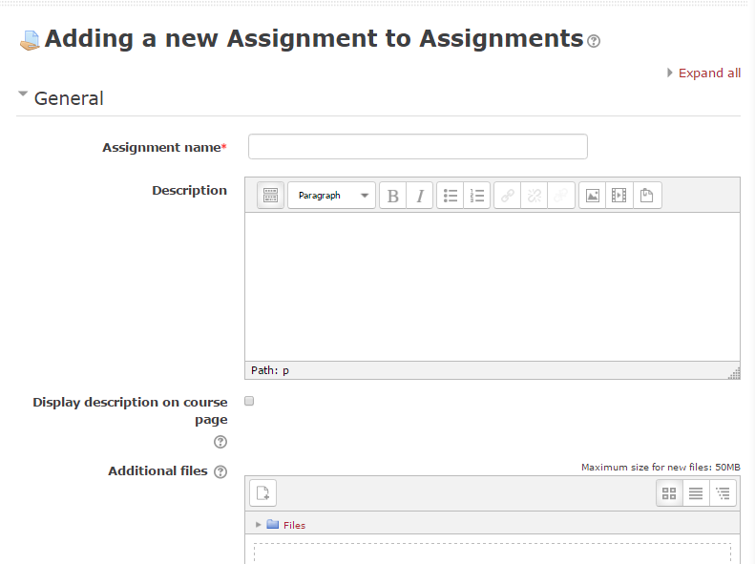
The "Adding a new Assignment page" will appear.

Assignment Settings
- Type an Assignment Name: The Name will be the title of the assignment along with the associated Moodle module. Choose a name that is specific and clear for easy student navigation. (example M2 Assignment Essay- Public Schools, where M2 stands for Module 2)
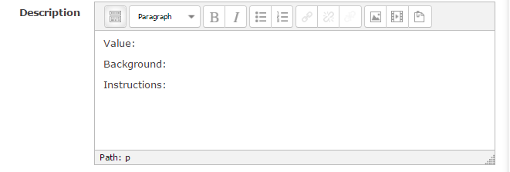
- Description. The description is very important. The student will use the assignment description to guide them in successfully completing the assignment. The Description should have three headings:

Value: Is this a graded assignment? Is it a required assignment? If so, how much is this assignment weighted towards (%) the final grade?
Background: Why is completing this assignment important? How does it relate to the learning outcomes?
Instructions: The instructions may be twofold:
1. Review the steps to complete the assignment. If the steps to complete an activity or assignment are sequential, use numbers to identify steps. If it is a non-sequential activity or assignment, put the steps in bullet points.
2. Review how to upload the assignment into Moodle. (If this is the first assignment in a course, you may want to include these instructions. Otherwise, you may choose to have a link to these instructions.)

- Availability:
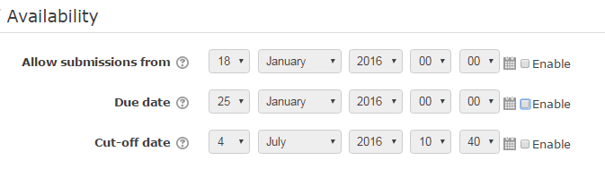
Select the dates for the assignment by clicking on the Enable box.
Allow submissions from: If you do not enable, students will be able to start submitting right away.
Due date: This is when the assignment is due. Submissions will still be allowed after this date but will be marked as late.
Cut-off date: If set, the assignment will not accept submissions after this date without an extension.
- Submission types:
Online text: Students are able to type text directly into an editor field for their submission.
File submissions: Students are able to upload file(s) as their submission.
Word limit: The Word Limit only works for Online Submissions. If selected, the student is unable to submit work beyond the selected word limit amount. See below.
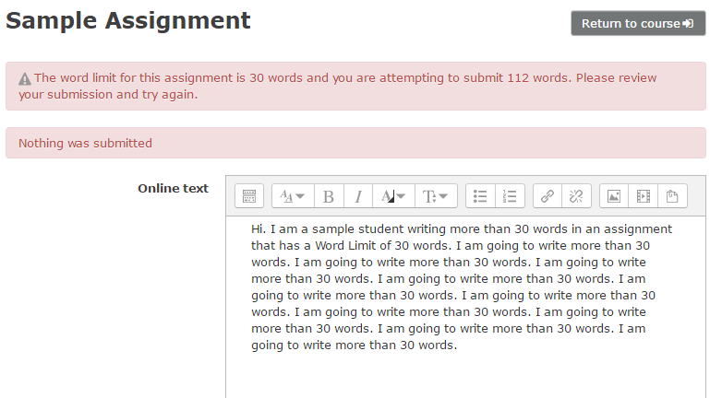

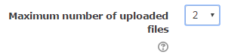
Maximum number of uploaded files: You may have an assignment that requires more than one submission. Even if you have one document due (an essay, for example), it is recommended that you select 2 for this setting in case a student submits the wrong work and/or wishes to make corrections prior to the due date. This may save the instructor time because they won’t have to revert the submitted work back to draft.

Maximum submission file: The default for the size of an uploaded file submission is set at 50MB, which should be appropriate for most assignments.
- Feedback types:
Feedback comments: If enabled, the instructor can leave feedback comments for each submission.
Feedback files: If enabled, the instructor will be able to upload files with feedback when marking the assignments.
Offline grading: If enabled, the instructor will be able to download and upload a worksheet with student grades when marking the assignments.
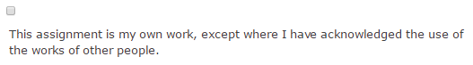
- Submission settings:
Require that students click submit button: If enabled, students will have to click a submit button to declare their submission as final. This allows students to keep a draft version of the submission on the system.
Require that students accept the submission statement: If enabled, students must click a box indicating the work is their own.
Attempts reopened: Determines how attempts are reopened: Never, Manually (by the instructor only), Automatically until pass (set by the instructor in the assignment Grade Settings section.
Maximum attempts: The number of attempts that a student may submit. (Default 1)
- Group submission settings: Please see Miscellaneous Moodle Information to learn about Groups and Groups in Moodle.
- Notifications: Choose notifications about submitted assignments for students or instructors.
- Grade settings:
Grade: Specify the maximum grade or scale to be applied to the assignment. If you will not be giving a grade for this assignment, choose "No grade."
Grading method: Select a grading method.
Simple direct grading: Enter a grade or scale item.
Rubric: Advanced grading used for criteria-based assessment. (See Assignments - Rubrics)
Marking guide: Advanced grading. A teacher enters a comment per criterion and a mark. (See Assignments- Marking guides)
Grade category: Select the required Grade category to add this assignment.
Blind marking: Hide the student information from the marker while they are marking the assignment.
Use marking workflow: If enabled, marks will go through a series of workflow stages before being released to students. This allows for multiple rounds of marking and allows marks to be released to all students at the same time.
Use marking allocation: If enabled together with marking workflow, markers can be allocated to particular students.
- Common Module Settings: Use this section to hide the assignment or assign groups.
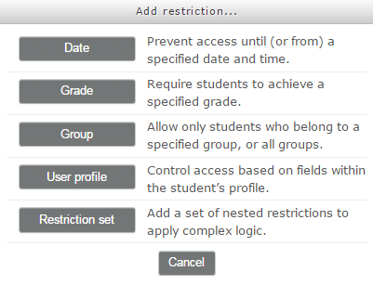
- Restrict access: Allows you to not have the assignment open until certain criteria are met.

- Click on the Save and return to course button or the Save and display button.
For more information see Moodle docs Using Assignments or contact Moodle Help.

